Performance Baseline
Device model: Android emulator – Medium Phone
SoC: Emulated x86_64 CPU
RAM: 2048
OS Version: Android 16.0 API 36.1
Battery health estimate: NA

Frame-time average
CPU: 2ms
GPU: 2ms
Average: 4ms
99th percentile: 5ms
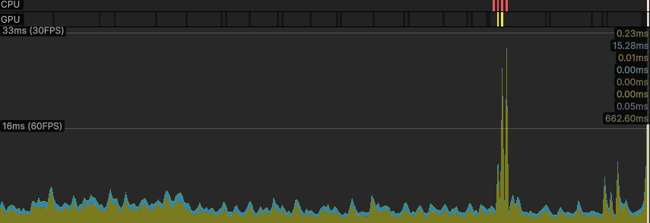

Cold start time: 12s
APK size: 49,911 kb
- Frame-time average & 99th percentile (ms), CPU vs GPU time, GC allocs/frame, peak memory, draw calls/batches, set resolution/scale.
- Thermals: starting temp, 10-minute play temp delta, any throttling observed.
- One bottleneck identified and one fix implemented since W6 (with 2–3 sentences and a before/after metric).

